**CANTEEN ORDERING SYSTEM FOR UNILEVER**

#### Unilever Logo and symbol, meaning, history, PNG, brand

Simplilearn project 1 CBAP Submit by: Ashish Prasad

**Table of content:**

|  |  |  |
| --- | --- | --- |
| No. | Topic | page |
| 1 | Introduction | 3 |
| 2 | Business Analysis Core Concept Model (BACCM) | 4 |
| 3 | Objective of the new canteen order system | 5 |
| 4 | Current and future scope (flow chart) | 6 |
| 5 | Scope of the Canteen Ordering System (context diagram) | 7 |
| 6 | The main features that need to be developed | 7-8 |
| 7 | In-scope and Out-scope items in the software | 8 |
| 8 | Activity diagram for the system: Swim Lane diagram | 9 |
| 9 | ER diagram of the system | 10 |
| 10 | The functional and non-functional Business requirements | 11 |
| 11 | Wireframe for the canteen order system | 12 |
| 12 |  |  |

**TASK 1:**

**Introduction**

Project Overview

Unilever is a British-Dutch MNC FMCG company, headquartered in London, England. Unilever is one of the oldest FMCG companies, and its products are available in around 190 countries. In its UK offices, Unilever had around 1500 employees which were spread across 12 floors. They had 2 canteens to cater to these 1500 employees. Each canteen could seat around 150 employees at a time.

Most employees would prefer to take their lunch between 12 noon to 1 pm. This led to a huge rush in the canteen during lunch hours resulting in employees wasting a lot of time waiting for tables to be vacant.

Management calculated that it took around 60 minutes for employees to go and come back from lunch. Almost 30-35 minutes were wasted in waiting in a queue to collect their food and get a table to sit and eat. However, the time spent eating was barely 10-15 minutes. The remaining 10 minutes were spent reaching and coming back from the canteen using the elevators.

Employees don’t always get their choice of food they want because the canteen runs out of certain items. The canteen wastes a significant quantity of food by throwing away what is not purchased.

Many employees have requested a system that would permit a canteen user to order meals online, to be delivered to their work location at a specified time and date.

**TASK 2:**

# **Business Analysis Core Concept Model (BACCM)**

Need:

In Unilever they had 1500 employees in UK Office, which they need to cater across 12 floors and each canteen they could seat around 150 employees at a time. So, they need to reduce the wasted time waiting in a queue.

Change:

To reduce the queue line or waiting for a table to vacant we can introduce the token system as per floor wise, or we can order food online through website that reduce the waiting time and reduce the wastage of food.

Solution:

We can develop an App that allow employees to order food through application. which help them to reduce the queue line and reduce the time by provide the food to their workstation that reduce the 60 min to 20-30 min time.

Stakeholder:

|  |  |  |  |
| --- | --- | --- | --- |
| **Keep Satisfied** | **Manage Closely** | **Monitor** | **Keep Informed** |
| Sponsor | Development Manager | Supplier | Developer |
| Canteen Manager | Project Manager | Menu Manager | Tester |
| Unilever Employees | Implementation SME | Payroll Manager | Operational Support |
| Management |  | Chefs |  |

Context:

After implement the application it will reduce the waiting time and get the food at their workstation also reduce the waiting time. It helps to reduce the extra manpower cost incurred in a canteen.

Value:

It will reduce the wastage of food and operating cost also help to increase the efficiency and the no rush during the canteen lunch time

**RACI MATRIX**

1. Responsible ‘R’: The persons who will be performing the work on the task.
2. Accountable ‘A’: The person who is ultimately held accountable for successful completion of the task and is the decision maker. Only one stakeholder receives this assignment.
3. Consulted ‘C’: The stakeholder or stakeholder group who will be asked to provide an opinion or information about the task. This assignment is often provided to the subject matter experts (SMEs).
4. Informed ‘I’: A stakeholder or stakeholder group that is kept up to date on the task and notified of its outcome.

|  |  |  |  |  |
| --- | --- | --- | --- | --- |
| **Stakeholders** | **Responsible** | **Accountable** | **Consulted** | **Informed** |
| Project Manager |  | A |  |  |
| DSME |  |  | C |  |
| ISME |  |  | C |  |
| Employee |  |  |  | I |
| Canteen Manager | R |  |  |  |
| Operational Support (IT) |  |  | C |  |
| Chefs | R |  |  |  |
| Delivery Boy | R |  |  |  |
| Payroll Team |  |  |  | I |
| Business Analyst | R |  |  |  |
| Tester | R |  |  |  |



Problem statement:

1. The problem face by Unilever is that there are 1500 employees and only 2 canteens to cater.
2. Employees are waiting in a queue around 30-35 minute.
3. Lack of management system in canteen and wastage of food.

**TASK 3:**

**Objectives**

* Reduce canteen food wastage by a minimum of 30% within 6 months of the first release of the ordering system.
* Reduce canteen operating costs by 15% within 12 months of the first release of the ordering system.
* Increase the average effective work time per employee per day by 30 minutes within 3 months of the first release of the ordering system.
* Operate with less manpower in the canteens by making the ordering process automated and delivering the food to the employee’s workstation.

**TASK 4:**

**Current state**

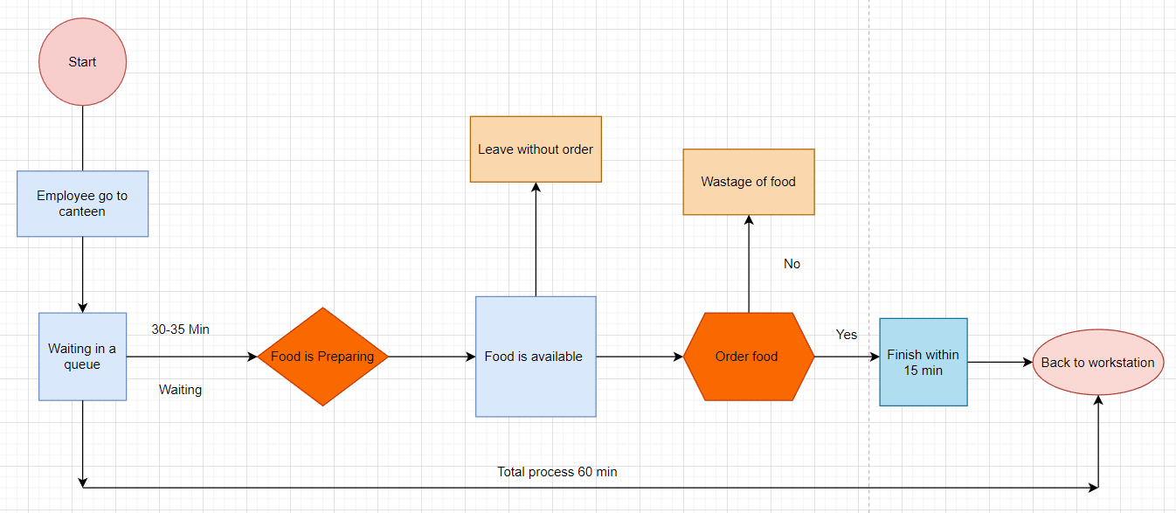

**Future state**

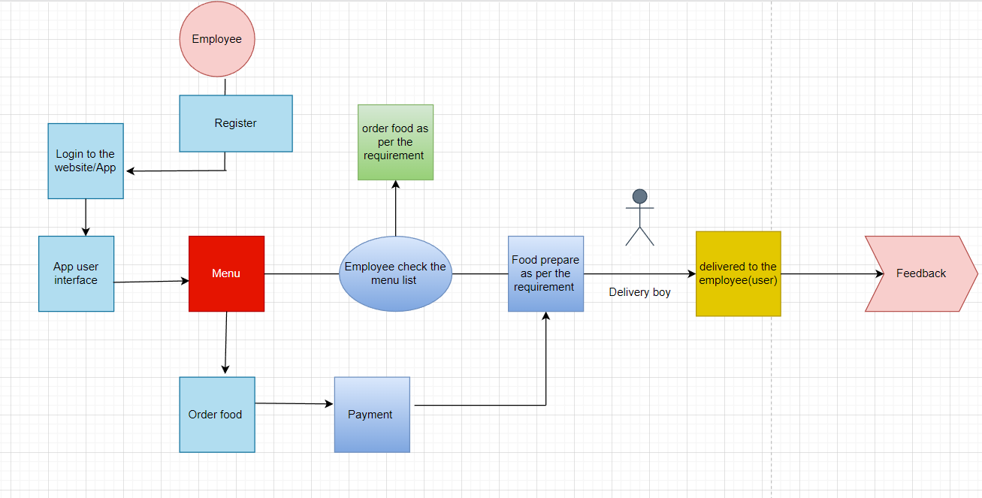

**TASK 5:**

**Scope of the Canteen Ordering System (context diagram)**

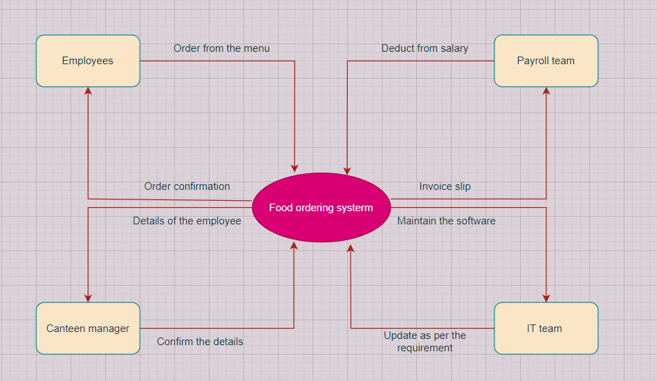

**TASK 6:**

**The main features that need to be developed:**

* Mobile application or website login criteria.
* At a time 1500 Employee can login easily.
* Basic registration details

-Name

-Emp ID

- Department

- floor

- Password

* Employees can update or edit before confirming the final order.
* No changes have been made once order confirmed so avoid wastage.
* Canteen manager check the order summary and instruct the chefs.
* Canteen manager assign the delivery boy to deliver to the employee desk.
* After deliver the food, delivery boy closes the order as delivered.
* Feedback option should be them to modify or change the menu that reduced the wastage.
* IT team send the order detail to the employee
* Order confirmation
* Track order detail

**TASK 7:**

**In-scope items for this software:**

1. Employee sign/sign out
2. Home screen
3. Menu page
4. Payment screen
5. Order confirmation page
6. Feedback submission
7. Monthly payroll detail
8. Sales report for canteen management

**Out-of-scope items for this software:**

1. Supply of food details
2. Canteen sitting capacity
3. Chefs and staff information
4. Pre-order requirement
5. Refund option
6. Chefs and meals payment detail

**TASK 8:**

**Activity diagram for the system: Swim Lane diagram**

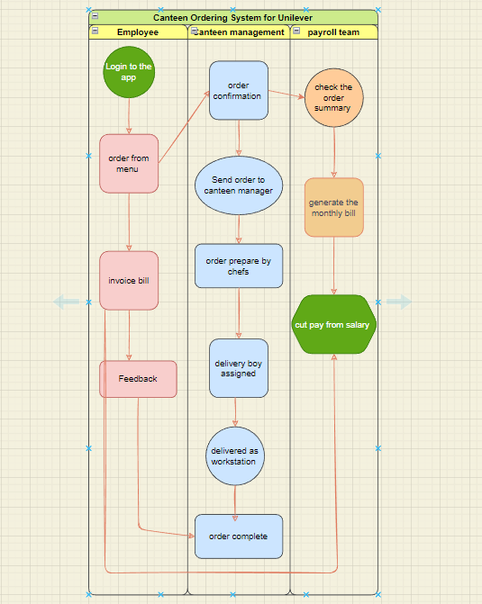

**TASK 9:**

**ER diagram of the system**

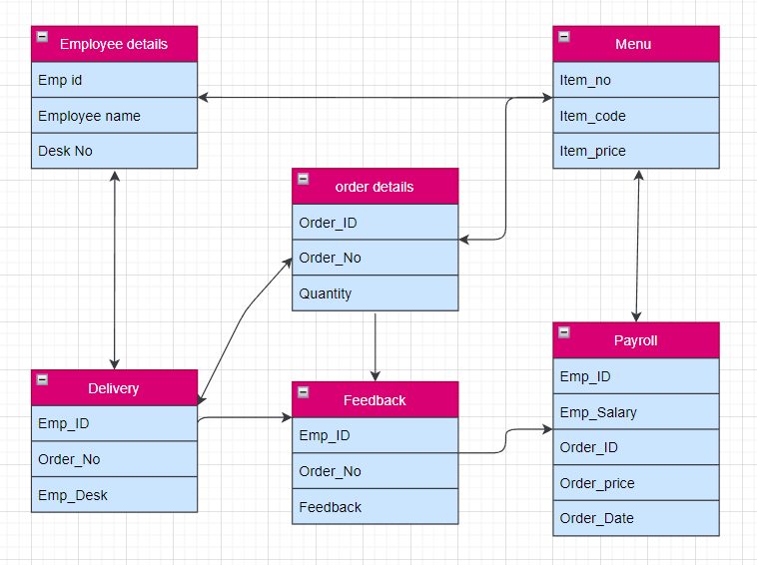

**TASK 10:**

**The functional and non-functional Business requirements**

**Functional requirement:**

1. **Login and register.**

-Appropriate login criteria for every employee.

-Login with employee and desk no.

1. **Open the Menu**

- list of foods in a menu

-Check the meal for the day

1. **Order from Menu**

-Order from the menu before 11 am

1. **Payment gateway**

-Provide the employee id

-Desk Number to get the order

1. **Check the order**

-Check order summary

-Assign the delivery boy

1. **Order confirmation**
2. **Feedback submission**

-Feedback as per the meal

1. **Payroll deduction**

-Record the employees meal

-Frequency of the order

-Monthly invoice bill

1. **Report**

-generate canteen order summary

-Overall food wastage

-Employee payroll record

-update meal as per the feedback

**Non-Functional requirement:**

* 1. **Scalability**

**-**The Software is ready to use to cater 1500 employees.

* 1. **Compatibility**

-It maintains 1500 employees at a time.

* 1. **Performance efficiency**

**-**The system will be east to use and perform fast.

* 1. **Reliability**

-It is reliable to cater the system smoothly.

* 1. **Usability**

**-**It is user friendly and easy to access.

* 1. **Security**

**-**The software is secure and free from virus**.**

**TASK 11:**

**Wireframe for the canteen order system**

